Information about relocation to a new central warehouse – important clarifications for suppliers

Dear supplier,
We would like to inform you that Ahlsell Norge AS will relocate its central warehouse from Gardermoen/Nordkisa to new premises in Eidsvoll. The relocation will start in summer 2026 and will be carried out in several phases, with the goal of completing the move by week 45 2026.
The relocation is part of the continued development of our logistics platform and will provide increased capacity, more efficient delivery processes, and better predictability in our cooperation with our suppliers.
To ensure a smooth transition, it is important that you familiarize yourselves with the following information.

📍 Delivery address – new central warehouse
The new delivery address will be:
Ahlsell Norge AS – Central Warehouse Eidsvoll
Korneliusmyrvegen 49
2074 Eidsvoll Verk
Norway
Important clarification:
Deliveries must always be made to the delivery address shown on each individual purchase order. Suppliers must not change the delivery address on their own initiative.

🗓️ Timeline and transition period
The relocation will take place step by step from week 23, with parallel operations between the existing warehouse in Nordkisa and the new warehouse in Eidsvoll during parts of the period.
- You will be notified by the responsible buyer at Ahlsell when deliveries from you are to be transferred to the new central warehouse.
- The change will also be clearly shown in the delivery address on our orders.
- During the transition period, some suppliers may be asked to deliver to both locations, depending on product category and progress in the relocation plan.
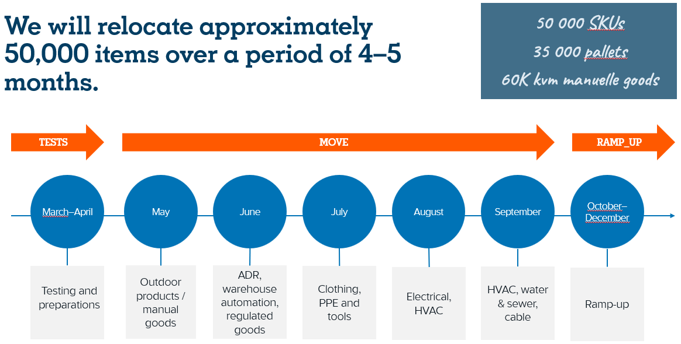

🚚 Unloading and delivery routines
In connection with the start-up of the new central warehouse, updated delivery routines will be introduced, including:
- Opening hours for delivery of goods – normally 07:00–15:00 (Monday to Friday)
- New gates and access roads (follow signage/guidance upon arrival)

📦 Labelling and documentation
All deliveries must meet the requirements set out in Ahlsell’s current logistics appendix. This appendix also applies in full to deliveries to the new central warehouse.
Insufficient labelling or deviations from the established requirements may lead to delays or rejection upon receipt.

🚛 Transport and planning
The new warehouse location may affect transport time and route planning. Suppliers are responsible for adapting their own transport set-ups in accordance with the applicable delivery address and routines.
We recommend planning deliveries well in advance during the transition period. If circumstances may have a significant impact on delivery reliability or lead times, we ask for early dialogue.

👥 Contact
If you have questions related to the relocation, delivery routines, or the transition to the new warehouse, please contact your purchasing contact at Ahlsell.

We thank you for the good cooperation and greatly appreciate flexibility and good dialogue in the period leading up to full operations at the new central warehouse in Eidsvoll.

Kind regards
Ahlsell Norge AS

